|  |  |  |
| --- | --- | --- |
| **Report IDM reference No.** | *EFDA_D_2MSYNS* | **Version: see IDM** |

Final Report

on Deliverable

*MAT-1.1.1-T2-D1 Summary overview document on EDDI Co-ordination activities*

|  |  |  |  |
| --- | --- | --- | --- |
|  | | **Deliverable-ID**[1] | *MAT-1.2.2-T010-D1* |
| **Work Package** | *WPMAT* | **Date** | *20 Dec 2016* |
| **Project Leader** | *Michael Rieth* | | |
|  | | | |
| **TS Title** | *CuCrZr Support* | | |
| **TS Ref. No.** | *TS 1.2.2-T010* | **TS IDM-link** | [2N6WHA](https://idm.euro-fusion.org/?uid=2N6WHA&action=get_document) |
| **Task Owner** | *Chris Hardie* | | |
| **RU(s)** | *CCFE* | | |

|  |  |
| --- | --- |
| **Report Review & Approval** | |
| **IDM role** | **Name(s)** |
| **Author** | *Chris Hardie* |
| **Co-author(s)** | *-* |
| **Reviewer(s)** | *M. Gorley* |
| **PMU Reviewer** | *E. Diegele* |
| **Approver** | *M. Rieth* |

|  |  |  |  |  |  |
| --- | --- | --- | --- | --- | --- |
| X | Study / Assessment |  | Procurement / Commissioning of Hardware |  | Industry |

|  |  |  |  |
| --- | --- | --- | --- |
|  | Use of Facility |  | Other *{please specify}* |

|  |
| --- |
| **Executive Summary** |
| This report follows work reviewing CuCrZr within EDDI in 2014. This small literature review considers recent work following the previous review to provide an update. CuCrZr manufacture, fabrication, thermal loading, corrosion, erosion and tritium retention is discussed. Additional CuCrZr database information, including placeholder values from the WPMAT-IRRAD project were introduced into the database. |

|  |
| --- |
| **Comments** (shortcomings, deviations, etc.) |
|  |

*{Guidance on Report format given below, this is not mandatory and can be modified as required}*

**Table of Contents**

1 Short Introduction and Objectives of Work 2

2 Description of Work 3

2.1 Manufacture 3

2.2 Fabrication and joining 5

2.3 Thermal damage 6

2.4 Corrosion and Erosion 8

2.5 Tritium Retention 8

3 Conclusion 9

4 References 9

# Short Introduction and Objectives of Work

This report describes support work for CuCrZr knowledge and development within EDDI in 2016 and follows from the work conducted within the same project in 2014. Previous work within EDDI consists of a review of CuCrZr baseline material for application within a DEMO environment [1] and design recommendations for a CuCrZr database [2], both of which were produced by the current author in 2014. Previous work within focused on the degradation of CuCrZr subject to irradiation, which is of primary concern for DEMO applications. The current work consists of a literature survey which provides an update of CuCrZr baseline material for DEMO application by considering recent studies from 2014 onwards. These developments are focused on some of the more practical aspects of CuCrZr and do not repeat the concerns regarding irradiation of CuCrZr which were addressed in the previous review [1].

# Description of Work

As described in previous work [1] application of the CuCrZr system in DEMO has restrictive and detrimental design limitations owing to the vulnerability of the precipitation hardened microstructure in an irradiation environment. Several opportunities for optimisation of the alloy exist, yet there potential effectiveness is currently unknown and without prior research these remain highly speculative. Consequently, it was recommended to specify the ITER grade of CuCrZr for DEMO applications and benefit from the extensive development and database work undertaken to date. The aforementioned design limitations this imposes on DEMO, particularly the incredibly small operational temperature window of CuCrZr [3], manifests a considerable risk to the engineering feasibility of DEMO.

The most recent work found in the open literature relates to current concerns in manufacture, fabrication and joining, performance under thermal loading, corrosion and tritium retention.

## Manufacture

One of the conclusions in the Baseline of CuCrZr for DEMO [1] was that the application of cold work after solution annealing may maintain work hardenability in the irradiated material whilst preserve ductility and fracture toughness [4]. However it has also been shown to enhance irradiation induced softening following irradiation at high temperatures [5].

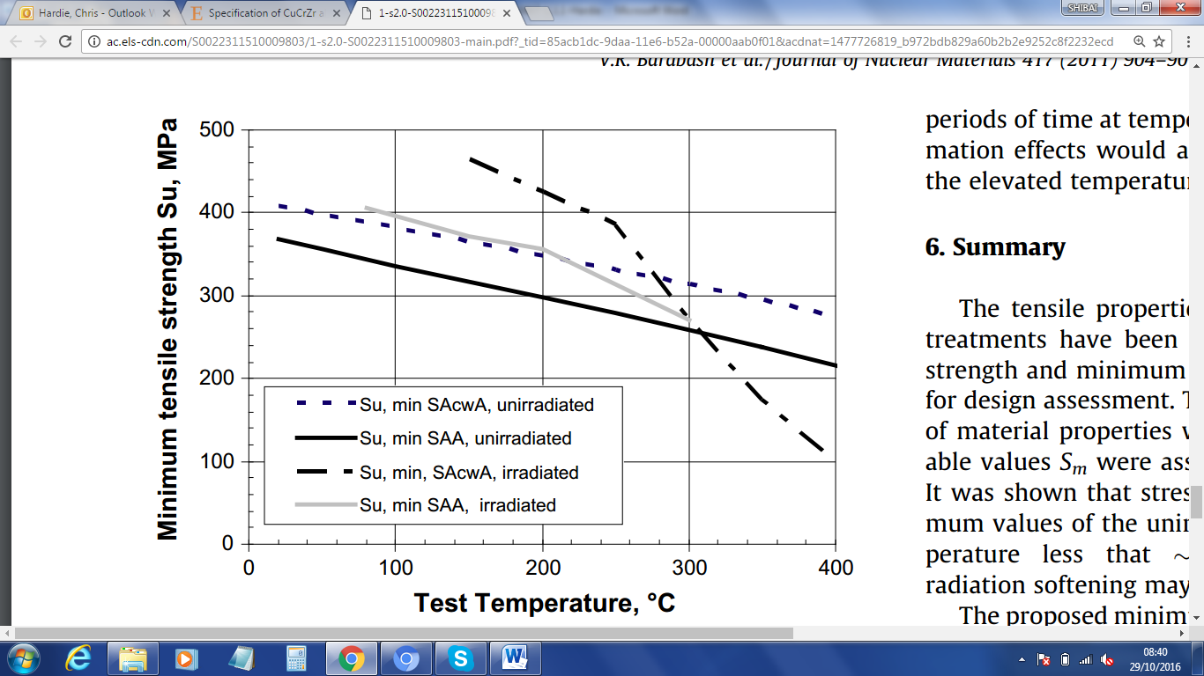

Figure : Minimum tensile strength before and after irradiation (>0.5dpa) of CuCrZr in the peak aged (SAA) and cold worked peak aged (SAcwA) conditions [5].

Further work has been conducted on this subject, including the use of equal channel angular pressing (ECAP) [6] to induce cold work in the CuCrZr system. Kvackai et al. [7] investigated the effect of ECAP on the CuCrZr system by use of tensile tests. After one ECAP pass with a channel angle of φ=90°, ψ=32° and a diameter of 10mm, the yield stress of CuCrZr in the solution annealed condition increase by 236MPa. Further strength was achieved upon ageing the material after ECAP, however this was not compared to the same material aged without ECAP and therefore it is not possible to compare the effect of ECAP on the strength of the final alloy product from this work. Unfortunately no data or information regarding the tensile properties other than yield stress was reported; therefore it is also not possible to comment on the effect of ECAP on the ultimate tensile stress and ductility of this material. The additional strength achieved by ECAP was attributed to grain size refinement, however in an alloy system highly limited and susceptible to creep by grain boundary sliding (Coble creep), the use of this technique for improved strength must be assessed with potential implications of creep resistance also (for example see ref. [8]).

Interestingly work by Wang et al. showed that the tensile strength and ductility of pure copper can be improved simultaneously by inducing work at cryogenic temperatures [9]. This phenomenon has since been investigated for CuCrZr alloy by Belyaeva et al. [10], who investigated the effect of ECAP followed by so called Quasi-Hydrostatic Extrusion (QHE) at room temperature and at liquid nitrogen temperature (77K). Microhardness tests appear to have been undertaken on a sputtered surface following sputtering resistance experiments reported in [11, 12]. The condition of the material is not reported and difficult to ascertain from previous publications, however according to [12] it appears that the QHE was undertaken on a CuCrZr alloy subjected to ECAP and subsequent ageing at 450 °C for 1 hour. Sputtering by deuterium ions revealed the precipitate microstructure where it appears QHE at 77K leads to a higher dispersion and more homogeneous distribution of precipitates compared to QHE at 300K, although no quantitative measurements were reported. It was shown that the lower diffusion rates and recrystallization in the material subjected to QHE at 77K compared to 300K, resulted in higher grain refinement and greater homogeneity of the precipitate structure. Unsurprisingly the measured hardness was higher for the material extruded at 77K compared to that extruded at 300K, however these results do not indicate the alloys resulting ductility and fracture toughness which may be affected.

Ihira et al. have investigated the effect of cryo-rolling (rolling at liquid nitrogen temperature) on CuCrZr prior to ageing by tensile testing [13]. Unlike that reported for pure copper [9], CuCrZr did not exhibit enhanced ductility in the cryo-rolled, recrystallized/aged state compared to the conventional as-received alloy. A higher tensile strength was achieved in the cryo-rolled CuCrZr which was attributed to the enhanced grain refinement achieved at cryo-temperature. Additionally, observed differences in the rolling direction texture between cryo-rolled (exhibiting {110}<1-12> brass and {110}<001> Goss orientation) and cold rolled (exhibiting {112}<11-1> copper orientation) Cu and CuCrZr can be attributed to the variation of stacking fault energy at these temperatures [14]. It is proposed that the predominantly higher Schmid factors associated with the brass and Goss orientation texture give rise to enhanced strength and ductility in the rolling direction. Considering all tensile data reported were from specimens fabricated such that the tensile axis was parallel to the rolling direction, further work is required to understand if the mechanical benefits of such texture are lost or even degraded in other orientations compared to an alloy with no texture. Finally, initial engineering stress-strain results from cryo-rolled material irradiated in the BR2 reactor at SCK-CEN were reported. These are shown in Figure 1. The alloys tensile properties appear unchanged following neutron irradiation to an approximate dose of 0.1 dpa at 290 °C, indicating lucrative potential for this alloy following manufacturing temperatures and operating temperatures below 475 °C. As discussed extensively in previous work [1], the effect of irradiation on CuCrZr goes through a transition from hardening to softening at approximately 290 °C as shown in Figure 3 [15]. Therefore, it is unfortunate that the apparent radiation resistance of cryo-rolled CuCrZr shown in Figure 2 may not be representative of irradiation at temperatures above and below 290 °C.

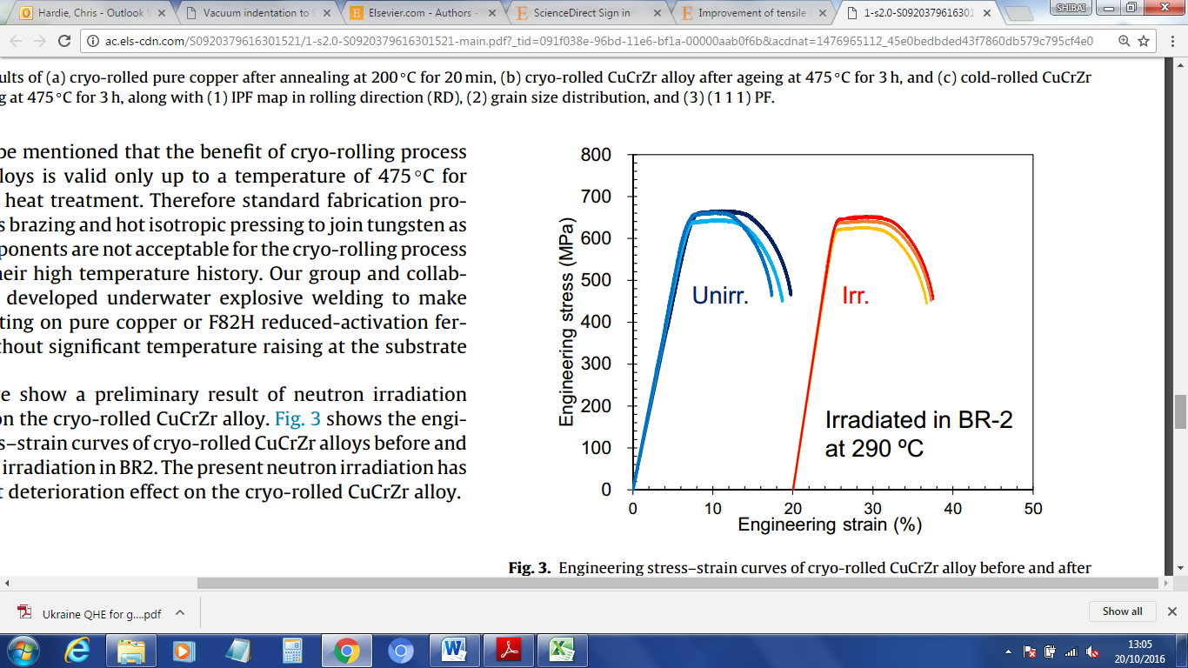

Figure : Engineering stress-strain curves for cyro-rolled CuCrZr in the un-irradiated and neutron irradiated condition (0.1dpa at 290°C) [13].

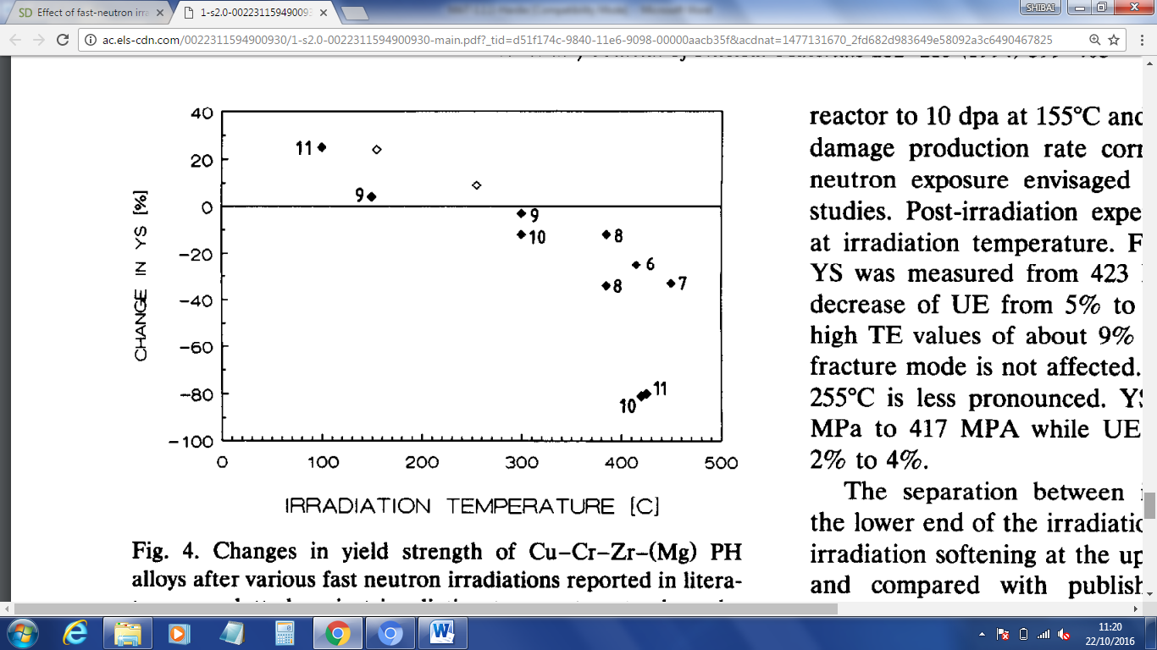

Figure : Irradiation-induced changes in yield strength of CuCrZr(Mg) alloys after various fast neutron irradiations, plotted against irradiation temperature (graph taken from ref. [15]).

## Fabrication and joining

Owing to superior thermal conductivity CuCrZr is chosen as a main candidate material for the underlying structural components of parts which are subject to high heat fluxes, therefore unimpeded thermal transfer from the plasma facing components subject to the high heat loads to the CuCrZr part is required [16]. A good example of a HHF part is the mono-block geometry for divertor design such as that used for the ITER divertor [17]. This consists of a CuCrZr pipe for water coolant, surrounded by tungsten with a pure Cu interlayer and joined by either brazing or diffusion bonding in the form of hot isostatic pressing (HIP) or hot radial pressing (HRP). The pipe geometry has exhibited a unique problem in thin sections such as the thin walled pipes used in the monoblock design, whereby coarse Cr precipitates appear to have caused linear ‘dimples’, scratches and even cracking on the surface of the Cu matrix during cold drawing [18]. This resulted in stress concentrators and strain localisation during circumferential deformation on joining by HIP/HRP and operation, making the pipe brittle in the circumferential direction and susceptible to failure by shear and cracking. Strong progress in the qualification of the ITER divertor design is being made, however in the absence of an accepted method to assess the circumferential mechanical properties of the CuCrZr pipe; this vulnerability in structural integrity of CuCrZr in this orientation may be overlooked.

A fairly common concern is the detrimental effect that high temperature manufacturing and joining processes have on the CuCrZr system. The effect of high temperatures during hot isostatic pressing (HIP) bonding has been investigated by Frayssines et al. [19]. The effect of Cr content at the lower ~0.5 wt.% and upper ~1.2 wt.% bounds of that specified EN 12420 and NF EN 12163, two HIP temperatures of 980 °C and 1040 °C and two different strain rates forming the billets were investigated. It was found that grain sizes following the HIP cycle were significantly larger for the lower Cr content and grain sizes were also larger for the higher HIP temperature. The grain sizes were shown to be slightly influenced by the billet forming strain rate where higher strain rates resulted in larger grains. Interestingly, the manufacture of CuCrZr IG using a powder metallurgy (PM) route and the classical HIP cycle of 1040 °C/140 MPa/2 h produced an alloy with a mean grain size of 20 µm; this is far smaller than smallest produced in the studies on cast material. The smaller grain size in the PM manufactured material did translate to superior impact toughness in both bulk and joint specimens compared to cast CuCrZr, however the PM material did exhibit lower tensile properties (slightly below ITER specification) perhaps due to a non-optimal chemical composition in the final alloy.

Novel joining processes such as field assisted sintering techniques and explosion bonding [20] do not impart high temperatures onto the materials to be joined and therefore offer the potential to produce joints between CuCrZr and stainless steel or tungsten, without detrimental effects to the mechanical properties. Additionally, the coating of tungsten on a surface of CuCrZr by chemical vapour deposition (providing a thickness of few tens of µm) [21] or galvanic electrodeposition (providing a thickness of few hundred µm) [22] may be used to provide a more optimum surface for joining larger sections of tungsten. Finally, the application of functionally graded material (FGM) is becoming a serious consideration since it overcomes problematic joining issues and relieves highly localised stresses due to thermal mismatch. Research on several methods has now been conducted including laser sintering, vacuum plasma spraying, microwave hot pressing sintering and more recently vacuum melt infiltration methods [16, 23, 24]. Further work is required to develop an FGM with sufficient density and thermomechanical properties, yet the feasibility of using vacuum melt infiltrated W-CuCrZr material has been demonstrated with positive results and the performance of this material subjected to high heat flux has been demonstrated [16]. The latter is discussed further in section 2.3.

## Thermal damage

As has been discussed earlier [1] application of CuCrZr in the divertor components is the most demanding environment for this material and aside from irradiation effects, the performance of CuCrZr under cycles of high heat flux is of notable concern. Work to assess the performance of CuCrZr subject to thermal cycling has been conducted by Chatterjee et al. [25]. Samples of a peak aged alloy (480 °C for 3 hours) and over aged alloy (500 °C for 3 hours) were subjected to several cycles which included 290 °C held for 60 s followed by water quench held at 10 s. The elastic modulus, electrical resistivity and lattice strain were measured periodically in-between selected cycles and damage mechanics was used to assess the degradation of the material, where [25]:

*Equation 1*

*Equation 2*

*Equation 3*

Where represents damage, is elastic modulus, is electrical resistivity, is strain and subscripts is the property after cycles and is the property at the beginning of the test (0 cycles). The damage to the alloy , is a fraction which increases with the number of cycles and was shown to exhibit saturation. The comparison of the alloys aged at 480 °C and 500 °C for 3 hours is shown in Figure 4.

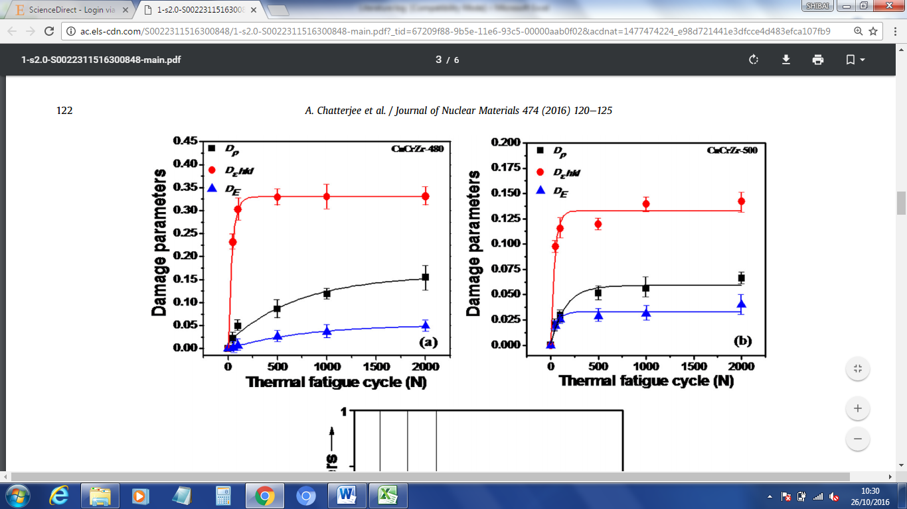

Figure : Variation in damage parameters , , as a function of thermal cycle number for CuCrZr aged at 480 °C and 500 °C for 3 hours [25].

The range of values on the y-axes for each alloy may indicate that the alloy slightly over aged at 500 °C has superior resistance to damage than the peak aged alloy. The initial absolute values for elastic modulus, electrical resistivity and lattice strain are important to confirm this conclusion, although these were not reported they are unlikely to differ substantially between both alloys before the thermal fatigue experiments.

Efforts to qualify designs such as the divertor monoblock for ITER [17] are stepping up and sophisticated high heat flux (HHF) testing is being used for this effort [26]. Several problems have been observed in an ITER monoblock mock-up during HHF testing at the IDTF electron beam facility (St. Petersburg, Russia) with 5000 cycles at 10 MW/m2 and 300 cycles at 20 MW/m2 corresponding to ITER qualification requirements [26]. The duration of each cycle was not reported, however this is typically 10 s for ITER qualification requirements as reported in ref. [27]. These include macro crack formation on the tungsten surface, pore formation and delamination in the Cu interlayer and of more relevance here, the formation of a low conductivity scale layer on the inside of the CuCrZr. This scale layer reduced thermal transfer and caused the temperature of the CuCrZr pipe to raise by ~195 °C to a maximum temperature of ~665°C. This temperature excursion resulted in plastic deformation visible on the outside surface of the pipe and may be particularly concerning if previously observed manufacturing defects exist in these structures which cause localised strain and cracking [18]. Corrosion of CuCrZr is discussed in further detail in section 2.4. In contrast to the multiple issues described by Pintsuk et al. [26], HHF testing on the aforementioned mock-up with FGM W-CuCrZr appears promising; however the mock-up was not tested with the number of cycles required for ITER qualification.

## Corrosion and Erosion

Corrosion of CuCrZr resulting from direct proximity with high pressure, high speed coolant water required for HHF components is a growing interest following concerning data which suggests high corrosion rates [28]. More recent work has confirmed that the corrosion and erosion of CuCrZr occurs at peak rates of 90 µm/year and 370 µm/year at 110 °C and 150 °C respectively during cyclic water chemistry conditions which simulate plasma activations of water cycling from reducing to oxidising [29]. The erosion rates of CuCrZr measured for the various conditions tested are shown in Table 1 [29]. Interestingly the corrosion and erosion rates were greatest during cycling of the water chemistry, where it is thought that the oxide film formed in oxidizing conditions is dissolved in reducing conditions when copper oxide is no longer thermodynamically stable.

Table : Estimated erosion corrosion rates (µm/year) of CuCrZr exposed under various simulated primary coolant water chemistries applicable to ITER operating conditions [29].

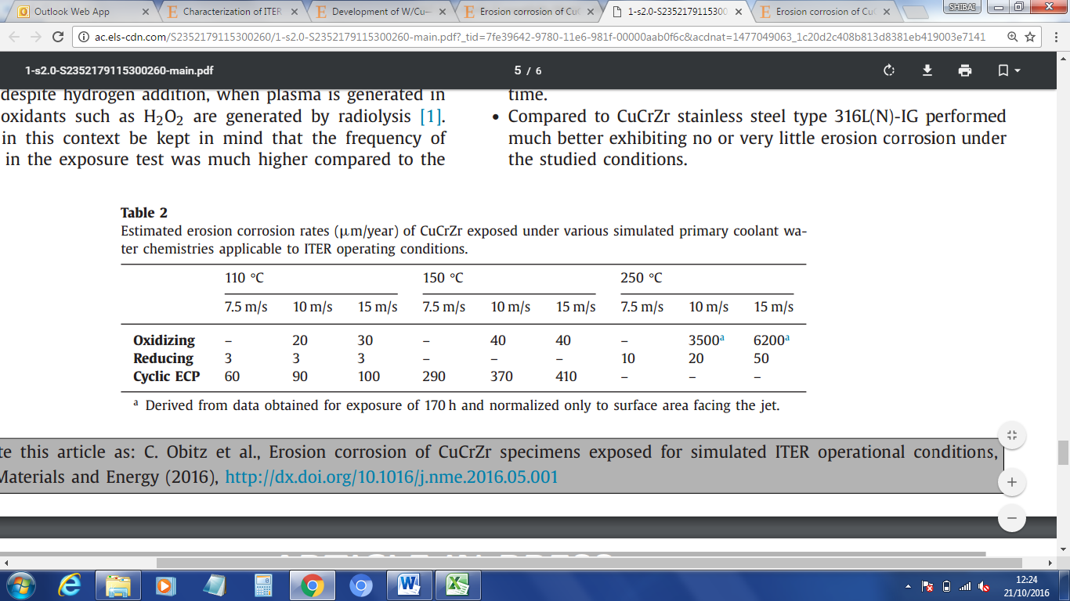

The loss of CuCrZr into coolant water is likely to be problematic for DEMO HHF applications where the reduction in wall thickness of CuCrZr affects structural integrity and radioactive isotopes are continuously released into the coolant. Additionally, the oxidation of CuCrZr has been shown to inhibit thermal transfer to the coolant water in the aforementioned HHF tests described in section 2.3 [26], which will compromise the thermal efficiency of the HHF components in DEMO.

## Tritium Retention

For application in ITER and particularly DEMO, control of reactor tritium inventory is important and little work on tritium retention properties of copper has been undertaken to date. The absorption and release of tritium has recently been reported by Otsuka et al. [30], however tritium was loaded in the sample at 873K (600 °C) therefore results cannot be related to peak aged (ITER grade) material. Tritium release was found to be much slower for CuCrZr compared to pure Cu, possibly due to Cr and Zr oxide at the surface of the alloy which has a high affinity to hydrogen isotopes. The retention of tritium at the surface is supported by heightened surface concentration of tritium, shown in images of β electrons produced by decay on a phosphor based imaging plate. Total retention of tritium in the surface of CuCrZr was shown to be slightly less than that of pure Cu (a retention ratio Cu:CuCrZr of 34.8:22.1) and far less in the bulk (a retention ratio Cu:CuCrZr of 26.8:1.6) [30].

Retained tritium also has been shown to increase He content in the CuCrZr alloy by the decay of tritium into helium. This has been shown to seriously impair the ductility of OFHC copper by promotion of integranular fracture due to helium cavitation at grain boundaries [31], therefore an oxide surface layer acting as a barrier to tritium permeation into the bulk may help prevent this degradation mechanism.

# Database Entries

As part of this task, new databases for CuCrZr have also been produced for tensile, fatigue and fracture properties. These databases were produced by adaptation of the steel based databases and not those produced in ref. [2]. Initial data have been added in the form of placeholders, where testing under the Eurofusion IRRAD will contribute. Little information was available for the IRRAD campaign and there are several details which would benefit addition into the database. For example the specific grade and treatment of CuCrZr-IG (treatment A, B or C) and orientation will have a significant effect on absolute values and relevance of results to engineers.

Additional work should be considered beyond that planned within the IRRAD project to fully exploit the material and investment made for its irradiation. This should include the production of an accessible specimen archive for reference and additional measurements such as modulus, electrical resistivity, thermal conductivity/expansion/specific heat, hardness (providing data over a full test temperature range), TEM and SEM Fractography.

# Conclusion

Without the extensive development and testing of alternative alloys, the CuCrZr-IG baseline grade is considered as the primary candidate for DEMO applications, maintaining the design limitations such as the small temperature window of operation which is currently imposed on irradiated component. Several recent investigations indicate possibilities for improved performance and could be considered for specific components in DEMO. For example, tailoring the texture of the alloy by forming processes at cryogenic temperatures could provide advantages in components such as pipes subject to directional loading. The use of severe plastic deformation at cryogenic temperatures should be considered for non-irradiated components such as beam dumps, however the technique requires further investigation on the effects of irradiation at several temperatures for irradiated components. Other manufacturing and fabrication routes, such as the use of powder metallurgy, coating technologies and new cold joining techniques have been demonstrated and offer potential for higher performance material in component form.

CuCrZr will be subjected to a unique, highly demanding environment in DEMO which standard tests do not fully represent, therefore work on more complex testing is now being undertaken. Several new defects and issues have been identified, including thermal fatigue damage, damage caused by HHF testing, corrosion, erosion and tritium retention, all which must be addressed for DEMO. Corrosion of CuCrZr has been identified following high heat flux testing of a monoblock mock-up component, which reduces thermal transfer to coolant water and results in an increase in the component temperature for a given loading condition. Additionally, concerning levels of corrosion and erosion of CuCrZr have been identified in DEMO relevant conditions, which would result in radioactive isotopes entering the coolant, a reduction of pipe thickness and resulting damage to structural integrity. Corrosion may be resolved by application of a protective coating, however no work has been found in this area. HHF testing also caused plastic deformation of the CuCrZr pipe, which demonstrates its vulnerability under complex loading conditions. Circumferential stresses are likely to be imposed on the CuCrZr pipe during HHF testing, where the strength of the material is not accurately represented by standard tensile tests. A method for circumferential integrity assessment for pipes should therefore be considered within design code development activities within EDDI.

Tensile, fatigue, and fracture based databases have been produced for CuCrZr and include placeholders for data to be produced under the IRRAD project beyond 2018.

# References

[1] Baseline review, EuroFusion, WPMAT, EDDI report (2014) – *[2LD6MH](https://idm.euro-fusion.org/IDM/Pages/DocumentView.aspx?uid=2LD6MH)*

[2] Database design, EuroFusion, WPMAT, EDDI report (2014) CuCrZr – *[2LA456](https://idm.euro-fusion.org/IDM/Pages/DocumentView.aspx?uid=2LA456)*

[3] Zinkle, S. J., and N. M. Ghoniem. "Operating temperature windows for fusion reactor structural materials." *Fusion Engineering and design* 51 (2000): 55-71.

[4] V. Barabash et al., ITER Material Handbook, IC CuCrZr alloy AK-02, G 74 MA 16 04-02-04 R0.2.

[5] Barabash, V. R., et al. "Specification of CuCrZr alloy properties after various thermo-mechanical treatments and design allowables including neutron irradiation effects." *Journal of Nuclear Materials* 417.1 (2011): 904-907.

[6] Valiev, Ruslan Z., and Terence G. Langdon. "Principles of equal-channel angular pressing as a processing tool for grain refinement." Progress in Materials Science 51.7 (2006): 881-981.

[7] Kvačkaj, Tibor, et al. "ANALYSIS OF METALLIC MATERIALS FOR ITER WITH THE EMPHASIS ON COPPER ALLOYS." Acta Metallurgica Slovaca20.4 (2014): 397-404.

[8] Wilshire, B., and C. J. Palmer. "Grain size effects during creep of copper."*Scripta materialia* 46.7 (2002): 483-488.

[9] Y. Wang, M. Chen, F. Zhou, E. Ma, Nature 419 (2002) 912.

[10] Belyaeva, A. I., et al. "Effect of quasi-hydrostatic extrusion on microhardness in CuCrZr alloy." Вопросы атомной науки и техники(2015).

[11] Belyaeva, A. I., et al. "Influence of grain size on resistance to ion sputtering of mirrors from low chromium–zirconium copper alloy." *Vopr. At. Nauki Tekhn., Ser. Thermoyad. Sintez* 4 (2011): 50-59.

[12] Belyaeva, A. I., et al. "Effect of microrelief on the optical characteristics of light Cr-Zr copper alloys bombarded by ions of deuterium plasma." *Bulletin of the Russian Academy of Sciences: Physics* 76.7 (2012): 764-767.

[13] Ihira, Ryota, et al. "Improvement of tensile properties of pure Cu and CuCrZr alloy by cryo-rolling process." Fusion Engineering and Design (2016).

[14] Bahmanpour, H., et al. "Effect of stacking fault energy on deformation behavior of cryo-rolled copper and copper alloys." *Materials Science and Engineering: A* 529 (2011): 230-236.

[15] Fenici, P., et al. "Effect of fast-neutron irradiation on tensile properties of precipitation-hardened Cu-Cr-Zr alloy." *Journal of nuclear materials* 212 (1994): 399-403.

[16] Greuner, Henri, et al. "Results of high heat flux testing of W/CuCrZr multilayer composites with percolating microstructure for plasma-facing components." Fusion Engineering and Design 98 (2015): 1310-1313.

[17] Ezato, Koichiro, et al. "Progress of ITER full tungsten divertor technology qualification in Japan: Manufacturing full-scale plasma-facing unit prototypes." *Fusion Engineering and Design* (2016).

[18] Zhao, S. X., et al. "Axial strain localization of CuCrZr tubes during manufacturing of ITER-like mono-block W/Cu components using HIP."Fusion Engineering and Design 89.12 (2014): 3083-3088.

[19] Frayssines, P. E., et al. "CuCrZr alloy microstructure and mechanical properties after hot isostatic pressing bonding cycles." Physica Scripta2014.T159 (2014): 014018.

[20] Sun, Congxiao, et al. "Bonding Interface of W–CuCrZr Explosively Welded Composite Plates for Plasma Facing Components." Journal of Materials Science & Technology 30.12 (2014): 1230-1234.

[21] Song, Jiupeng, et al. "Development of CVD-W coatings on CuCrZr and graphite substrates with a PVD intermediate layer." Journal of Nuclear Materials 455.1 (2014): 531-536.

[22] Jiang, Fan, and Yun Zhang. "Galvanic Electrodeposition of Thick Tungsten Coatings on CuCrZr Alloy." Journal of Fusion Energy 35.2 (2016): 281-288.

[23] Pintsuk, G., et al. "Development of W/Cu—functionally graded materials."*Fusion Engineering and Design* 66 (2003): 237-240.

[24] Xu, Lei, et al. "Fabrication of tungsten–copper alloys by microwave hot pressing sintering." *Journal of Alloys and Compounds* 658 (2016): 23-28.

[25] Chatterjee, Arya, et al. "Comparative study of approaches to assess damage in thermally fatigued Cu Cr Zr alloy." Journal of Nuclear Materials 474 (2016): 120-125.

[26] Pintsuk, Gerald, et al. "Characterization of ITER tungsten qualification mock-ups exposed to high cyclic thermal loads." Fusion Engineering and Design98 (2015): 1384-1388.

[27] Hirai, T., et al. "ITER full tungsten divertor qualification program and progress." *Physica Scripta* 2014.T159 (2014): 014006.

[28] S. Wikman, C. Gustafsson, J. Öijerholm, J. Eskhult. Paper presented at: 25th IAEA Fusion Energy Conference, Saint Petersburg, Russia (2014)

[29] Obitz, C., et al. "Erosion corrosion of CuCrZr specimens exposed for simulated ITER operational conditions." Nuclear Materials and Energy(2016).

[30] Otsuka, Teppei, et al. "Release behavior of tritium in pure copper and its alloys into pure water at ambient temperature." Fusion Engineering and Design (2016).

[31] Goods, S. H. "The influence of tritium exposure and helium build-in on the properties of OFHC copper." *Scripta metallurgica* 20.4 (1986): 565-569.

1.